Summer Fashion Versus Luxury Fashion: Which is India’s beauty bloom ?
Is India’s beauty defined by breathable summer wear or luxury glamour?
Discover how India’s vibrant summer fashion—from cotton sarees to eco-chic kurtas—outshines the glitz of high-end couture. With homegrown brands and cultural heritage leading the way, comfort meets style like never before.
Luxury dazzles on runways, but summer style blooms on every street across India.
Explore the fashion that truly reflects India’s soul—visit Dike Fashions today!
Click here: https://dikefashions.com/2025/05/26/summer-fashion-versus-luxury-fashion-which-is-indias-beauty-bloom/
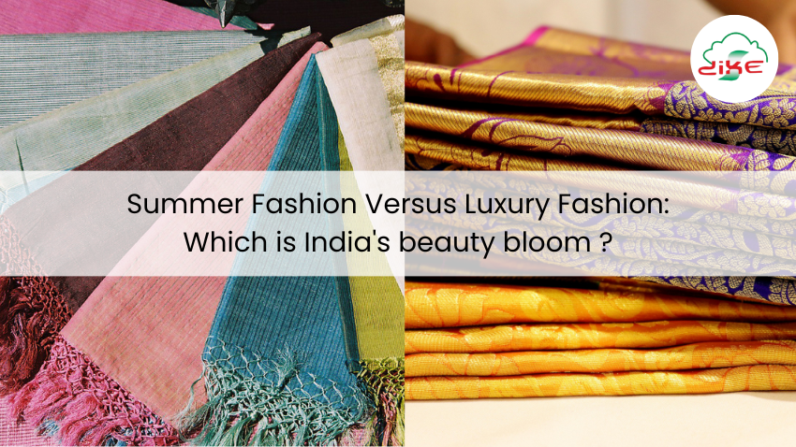

Affordable Summer Fashion, BestfabricsforIndiansummer, BollywoodStyleInspo , breathable fabrics for summer fashion , Chikankari kurti online , Comfortable Summer Wear, Cotton Briefs for Women , eco-friendly summer fashion brands , ethnic summer wear, Indian Summer Fashion Trends , Kalamkari sarees online, KhadiLove , lightweight summer clothing , summer casual wear , summer fashion 2025 , summer fashion accessories to beat heat , summer fashion colors , Summer Fashion for Women , summer fashion inspiration , summerfashiontips , summer kurtas ideas , Summer kurtis online , SummeroutfitsforwomenIndia , summer outfits ideas, summerstyleguide , SummerFashion, SummerOutfits , SummerStyle , SummerWear , Indian luxury fashion brands , Luxury fashion India . IndianSummerVibes.

